Wind Energy for Poster

“The coastal area of Lobito’s is very windy, and the whole north coast of Peru is known for constant high wind speeds. In a week in June 2020, for example, speeds averaged between 30-34 kph (19-21 mph)”

Why wind energy?

Wind turbines generate electrical energy by capturing the kinetic energy from the flow of wind for the blades to rotate. The rotations turn the internal shaft connected to the gearbox that increases the rotational speed for more spins to the generator that provides a larger power output. This power is sustainably formed to be directly distributed to the shredder machine, without producing harmful fossil fuels in the atmosphere.

Solid Wind SWP – 25KW (£14.254.71)

**Power**

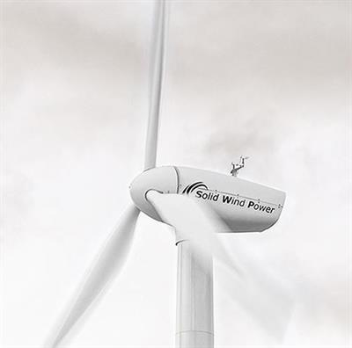Cut-in wind speed: 3.0 m/s

Rated wind speed: 11.0 m/s

Cut-out wind speed: 25 m/s

**Rotor**

Diameter: 14.0 m

Swept area: 314m2

Material: Glass-fibre reinforced plastic

**Gear box**

Type: Spur

Ratio: 1.22

Manufacturer: Sala

**Generator**

Type: Asynchronous

Voltage: 400.0 V

Grid frequency: 50.0 Hz

**Tower**

Hub height: 18m

Shape: conical

Type: Steel Tube

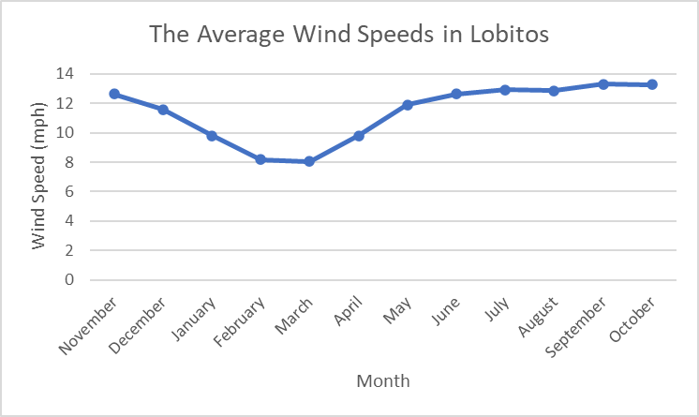

<https://wind-turbine.com/windkraftanlagen/90655/vestas-v20-100kw.html?utm_source=wind-turbine-models&utm_medium=cpc&utm_campaign=offers>

<https://en.wind-turbine-models.com/turbines/618-vestas-v20>

<https://weatherspark.com/y/17414/Average-Weather-in-Lobitos-Peru-Year-Round>